Team: Gauri, Tania, Isabella

Word count: 2995

**WHICH FACTORS AFFECT JUDGMENTS OF MANAGERS’ MORALLY QUESTIONABLE BEHAVIOUR?**

**1. INTRODUCTION**

**1.1 Overview: ethics judgment of managerial decisions**

The issue of ethics judgment is relevant in day-to-day business and management decisions. Managerial dilemmas are also ethical ones, representing the intersection between the firm’s “economic performance”, determined by factors like profits, and its “social performance”, determined by its effect on employees and those outside of the firm (Maclagan, 2012). Research on this topic can help understand factors contributing to managerial decisions, the impact of these decisions, and the way these actions are perceived by others. Ultimately, findings can contribute to the area of Business Ethics Education, aiming to “raise awareness and remind people of their moral obligations” (Maclagan, 2012). Students and managers who are often uncertain in their decisions can gain clarity on the resolution of their ethical dilemmas, with less unintended harm on others as a result.

In order to understand individuals’ ethics judgment of managerial dilemmas, this report examines the following research questions: *Can contextual factors preemptively alter the harshness of an individual’s ethics judgment? Furthermore, is there variation depending on the particular managerial decision being judged or the demographics of the individual making the judgment?*

**1.2 Influence of harm consideration and victim salience**

To begin with, we are interested in the influence of contextual factors before a decision is ethically judged, such as victim salience and harm consideration. *Victim salience* refers to a situation where the individual is made aware of victim characteristics resulting from a decision. Meanwhile, *harm consideration* induces the individual to contemplate in what ways their decision may have a negative impact. Indeed, it is important to consider the action’s impact on others, especially when it may cause harm. Interestingly, results over moral deliberation prior to ethics judgment through either harm consideration or victim salience are mixed.

On one hand, research has shown that intuition is associated with harsher moral judgment, as opposed to moral deliberation prior to the judgment. One study has shown that “deliberative decision making may actually increase unethical behaviors”, distracting individuals from “intuitive influences on moral judgments” (Zhong, 2011). Another study also displayed that “faith in intuition” leads to harsher moral judgment (Ward & King, 2018). Therefore, human intuition may be sufficient to ethically judge a decision.

On the other hand, some research claims that intuition is not sufficient and reveals moral deliberation to increase harshness of ethics judgment, calling for “critical moral thinking” described as “a full, empathetic identification with the beliefs, feelings, and interests of each person our decisions affect” (Maclagan, 2012). Both harm consideration and victim salience can be placed into this concept. More specifically, when moral standards are less prioritized and the details of a situation are vague, people are less likely to categorize morally ambiguous behaviors as unethical (Welsh & Ordóñez, 2014). This is logical as in such cases, it is easier to overlook certain ethical implications.

Finally, while ethics judgment may depend on contextual factors like victim salience and harm consideration, judged topic can also play a role. In the case of this study, the judged topics are where a) one employee is fired or b) the workload of five employees is increased by one hour and a half per day without pay raise. We wanted to consider the role judged topic as well, thereby focusing on the interaction of the victim salience and harm consideration with the judged topic.

In line with the second more intuitive perspective on the matter, we formulated our first two hypotheses:

*H1: The interaction between victim salience and judged topic has a significant effect on ethics judgment.*

*H2: When potential harm is considered first, people’s ethics judgment is harsher than if no harm was considered.*

**1.3 Gender influences**

Our study also aims to understand how demographic factors like gender influence ethics judgment. It is already known that “women are generally more inclined to act ethically than men” (Wang & Calvano, 2013), but also that, compared to female managers, male managers are more inclined to “justify” unethical behaviors. This can be explained by societal factors, as females seem to be more connected to the values of “collectivism” and “humane orientation”, while males are encouraged under a cultural context of “performance orientation” (Chen, Tuliao, Cullen, & Chang, 2016). Thus, it seems that women are more likely to ethically judge decisions more critically than men.

In addition, men and women respond differently to business ethics education with men actually being “more responsive” to it than women (Wang & Calvano, 2013), allowing us to question whether there are differences in the moral judgment of the topic being judged. Our hypothesis will evaluate the ethics judgment of “workload increase”, as the effect on ethics judgment as a whole already seems to be significant based on past literature. Our third hypothesis is:

*H3: When judging the ethicality of workload increase, women are more critical than men.*

**2. RESULTS**

The results of the statistical analysis are presented in three parts, each part representing the analysis of the corresponding hypothesis. We had the same dependent variable for all of our hypotheses: ethics judgment. To test our dependent variable, ethics judgment, we looked at two tasks in the questionnaire:

* Question 22 - ethics judgments of firing an employee
* Question 24 - ethics judgments of workload increase

To see the questions and how the answers were recorded, refer to APPENDIX section A.

**2.1. Victim salience and judged topic**

To test hypothesis H1, we compared three groups:

* Team 1 data, where victim salience is not mentioned.
* Team 4 data, with high victim salience for workload increase.
* Team 5 data, high victim salience for firing.

To see how salience was manipulated, see APPENDIX section A. It also provides a visualization explaining that LMX and harm consideration are not manipulated.

Firstly, we performed a Repeated Measure ANOVA, to examine the effect of two independent variables on ethics judgments: victim salience, which has 3 factors (teams 1/4/5) and judged topic, which has 2 factors (fire/workload increase). The output is presented in APPENDIX. The first table in Fig. 1.a. shows the six groups of people we obtained. Looking at Fig. 1.b. we see that the test of sphericity is not violated for the interaction effect between Salience and Judged Topic (Sig=0.207>0.05), so we will report “Sphericity assumed” results. Fig. 1.c. shows that the interaction effect between Salience and Judged Topic had a significant effect on Ethics Judgment (F(2,146)=3.586, p=0.030<0.05). This result is in support of H1. It means that victim salience affects ethics judgments, but its effect depends on the judged topic.

Then, we wanted to see for which topic victim salience had a more significant effect on ethics judgment, so we performed a Repeated Measure ANOVA for both topics separately. See fig. 2.a., 2.b. for the ANOVA for the topic fire. The independent variable is victim salience, which has 3 factors (teams 1/4/5). As Mauchley’s sphericity was not violated, we can assume sphericity. Salience had a significant effect on Ethics Judgment (F(2,146)=3.976, p<0.05). Therefore, victim salience is significant when judging the ethicality of firing an employee. See fig. 3.a., 3.b. for the ANOVA for topic workload increase. The independent variable is victim salience, which has 3 factors (teams 1/4/5). As Mauchley’s sphericity was violated, we report Greenhouse-Geisser results. Salience did not have a significant effect on Ethics Judgment (F(1.817,132.61)=1.773, p>0.05). Thus, victim salience is not significant when judging the ethicality of workload increase.

Finally, we wanted to see how victim salience affects ethics judgments when judging the ethicality of firing an employee. We performed three independent sample t-tests to compare the three groups in all salience conditions.

See fig. 5. for a t-test comparing Team 1 and 4. Salience had a significant effect on judging the ethicality of firing an employee(t(182)=2.316,p=0.022<0.05): when victim salience is not mentioned, people are more critical than when there is high workload increase salience (3.96<4.56). More specifically, when victim salience is not mentioned, people’s answer lies between “Mildly believe that it is not ethical” (3) and “Do not know” (4), but it is more inclined to “Do not know” (4). When there is high workload increase salience, people’s answer lies between “Do not know” (4) and “Mildly believe that it is ethical” (5), but it is more inclined to “Mildly believe that it is ethical” (5).

See fig. 6. for a t-test comparing Team 1 and 5. Salience did not have a significant effect on judging the ethicality of firing an employee(t(156) =-0.161,p=0.872>0.05). However, the means make sense: when there is high firing salience, people are more critical than when salience is not mentioned (3.92<3.96), but not on a significant level. More specifically, in both cases, people’s answer lies between “Mildly believe that it is not ethical” (3) and “Do not know” (4), but it is more inclined to 4 (“Do not know”) when victim salience is not mentioned.

See fig. 7. for a t-test comparing Team 4 and 5. Salience had a significant effect on judging the ethicality of firing an employee(t(172)=2.545, p=0.012<0.05): when there is high firing salience, people are more critical than when there is high workload increase salience (3.92<4.56) . More specifically, when there is high firing salience, people’s answer lies between “Mildly believe that it is not ethical” (3) and “Do not know” (4), but it is more inclined to “Do not know” (4). When there is high workload increase salience, people’s answer lies between “Do not know” (4) and “Mildly believe that it is ethical” (5), but it is more inclined to “Mildly believe that it is ethical” (5).

To sum up the t-tests for the topic firing, it seems that we get significant results only when Team 4 is involved. We get significant results when people’s attention is placed on the other victim (workload increase victim): people are less critical when judging the ethicality of firing an employee when they think about the victims of workload increase.

**2.2. Harm consideration**

To test hypothesis H2, we compared two groups:

* Team 2 data, with no harm consideration before judgment
* Team 6 data, with harm consideration before judgment.

To see how harm consideration was manipulated, see APPENDIX section A. It also provides a visualization explaining that LMX and victim salience do not differ.

Firstly, we performed an independent sample t-test testing ethicality judgments of firing an employee (see fig. 8.) Harm consideration had a significant effect on judging the ethicality of firing an employee (t(174.43) =3.026),p=0.003<0.01): when there is harm consideration before judgment people are more critical than when there is not (3.44<4.22). More specifically, when there is harm consideration before judgment people’s answer lies between “Mildly believe that it is not ethical” (3) and “Do not know” (4), but it is more inclined to “Mildly believe that it is not ethical” (3). When there is no harm consideration before judgment people’s answer lies between “Do not know” (4) and “Mildly believe that it is ethical” (5), but it is more inclined to “Do not know” (4).

Secondly, we performed an independent sample t-test testing ethicality judgments of workload increase (see fig. 9.) Harm consideration had a significant effect on judging the ethicality of workload increase (t(166)=2.213, p=0.028<0.05): when there is harm consideration before judgment people are more critical than when there is not (2.82<3.41). More specifically, when there is harm consideration before judgment people’s answer lies between “Moderately believe that it is not ethical” (2) and “Mildly believe that it is not ethical” (3). When there is no harm consideration before judgment people’s answer lies between “Mildly believe that it is not ethical” (3) and “Do not know” (4).

Therefore, the results are in support of H2, since we demonstrated that when potential harm is considered first, people’s ethics judgment is harsher than if no harm was considered, for both judged topics.

**2.3. Gender**

To test hypothesis H3, we looked at the data from all teams. Each gender is represented as follows:

* 1=male
* 2=female

We performed an Independent Sample t-test comparing the means of gender for both topics. See fig. 10. It seems that gender did not have a significant effect on ethics judgement for the topic of firing (p=0.619>0.05), so we will only look at the topic workload increase. For workload increase, gender had a significant effect on ethics judgment (t(455)=2.76,p=0.006<0.01): women were more critical than men for judging the ethicality of workload increase (2.89<3.33). These results are in support of H3. If we want to be more specific, we can say that women’s answer lies between “Moderately believe that it is not ethical” (2) and “Mildly believe that it is not ethical” (3). Men’s answer lies between “Mildly believe that it is not ethical” (3) and “Do not know” (4).

**3. DISCUSSION AND CONCLUSION**

**3.1. Summary and contributions to research**

In our study, the hypotheses tested the influence of victim salience, harm consideration and demographic factors such as gender on ethics judgement of the decisions taken by the managers.

The ﬁrst hypothesis of the study suggesting that the interaction between salience and judged topic did have a significant effect on ethics judgment was supported.

We get significant results when people’s attention is placed on the other victim (i.e. workload increase victim): people are less critical when judging the ethicality of firing an employee when they think about the victims of workload increase. Recent theory development and studies have emphasized the importance of stress in the reactions of individuals to job loss. Researchers have identified a number of variables which describe this reaction: distress, depression, irritation, anxiety, anger, hostility, etc. (e.g., Caplan et al. 1989; Cobb & Kasl 1977; Gore 1978; Kinicki & Latack 1990; Leana & Feldman 1990). Similarly, jobless individuals tend to display greater dissatisfaction with self compared to reemployed individuals (Stokes & Cochran 1984).

The second hypothesis of the study suggesting that when potential harm is considered first, people’s ethics judgment is harsher than if no harm was considered, for both judged topics (i.e workload increase and firing), was also supported.

This finding is consistent with the results of studies indicating an effect of harm consideration on ethics judgement. A study by Welsh, David T. and Ordonez, Lisa D.(2014) suggests that attention to moral standards increases sensitivity to one’s self-concept, making unethical behaviors more likely to damage self-image. This leads to a stricter view of “permissible conduct” - “when individuals are more attentive to their moral standards, they are more likely to categorize morally ambiguous situations as unethical”.

The third hypothesis of the study suggesting that women were more critical than men for judging the ethicality of workload increase was supported.

This finding contradicts studies that detected no gender differences regarding ethical judgment (c.f., Davis and Welton, 1991; Jones and Hiltebeital, 1995; Kidwell et al., 1987; McNichols and Zimmerer, 1985; Tsalikis and Ortiz-Buonafina, 1990). However, our findings seem to be consistent with other studies which did detect gender differences (c.f., Akaah, 1989; Ruegger and King, 1992;Chung-wen Chen, Kristine Velasquez Tuliao, John B. Cullen, Yi-Ying Chang, 2016) and supports the gender socialization theory that men and women bring different ethical standards to the work environment.

**3.2. Implications for practice**

Our research supports the continuing emphasis on victim salience, harm consideration and gender as important factors for influencing ethics judgement of managerial decisions. However, there is still a great deal of work to be done to better understand the effects of many other factors contributing to the manager's ethical approach. Ethical behavior can be influenced by managers’ personal characteristics, leadership and norm strength, etc. In this regard, this research is useful to scholars interested to understand better corporate ethical behaviors. Managers can also use the model to drive strategic changes in their organizations.

Additionally, this study indicates that women tend to be more critical than men in judging the ethicality of workload increase. Practitioners may want to use this knowledge when developing corporate ethics policies, professional codes of conduct, and rewards/punishment systems for unethical conduct (Khazanchi, 1995).

**3.3 Limitations and Future Research**

Results of this study suggest that the effects of victim salience, harm consideration and gender on the judgement of the ethical decision-making process should be further investigated in future studies.

The limitations of the present paper can also provide promising avenues for future research. The design of a future study could be more developed by not only emphasizing one ethical decision-making process (the manager’s) but by comparing the difference between several processes (ethical decisions involving the employer, the clients, or other decision-makers).

Population validity can also be improved as participants in this study were diverse in age, culture, profession etc., making it difficult to generalize results to a specific target population in the context of managerial decisions.

Moreover, our participants were asked to express their ethics judgments on a questionnaire which cannot be not seen or judged by others. However, in real life, our opinions are heard by others, so we tend to change them in order to appeal to them. A future study can therefore have people answering the questions in front of others instead of a questionnaire.

Finally, given the scarcity of management ethics research across countries, more research is needed regarding the area of management ethics in general. Future research can compare management ethics in different countries and sectors such as banks, public services and government organizations.

**APPENDIX**

1. **QUESTIONNAIRE**

ETHICS JUDGMENTS

* Question 22: *“Please rate the extent to which you think that firing one of the employees is ethical”*
* Question 24: *“Please rate the extent to which you think that increasing the workload of five employees by an hour and a half per day, without pay raise, is ethical”*

The answers were recorded on a scale of 1 to 7, 1 meaning “strongly believe it is not ethical” and 7 meaning “strongly believe it is ethical”. More precisely:

*1. strongly believe it is not ethical*

*2. moderately believe it is not ethical*

*3. mildly believe it is not ethical*

*4. don’t know*

*5. mildly believe it is ethical*

*6. moderately believe it is ethical*

*7. strongly believe it is ethical*

VICTIM SALIENCE AND JUDGED TOPIC

|  |  |  |  |
| --- | --- | --- | --- |
|  | **LMX** | **VICTIM SALIENCE** | **HARM CONSIDERATION** |
| **TEAM 1** | Not mentioned | Not mentioned | Not mentioned |
| **TEAM 4** | Not mentioned | High workload increase salience | Not mentioned |
| **TEAM 5** | Not mentioned | High firing salience | Not mentioned |

**Team 4**: Salience was manipulated with the following sentence:

“John knows that *increasing employees’ workload could have detrimental effects on their psychological, social and physiological well-being*. In particular, they may *experience stress.*”

**Team 5**: Salience was manipulated with the following sentence:

“John knows that *firing employees could have detrimental effects on their psychological, social and physiological well-being.* In particular, they may *experience stress*.”

HARM CONSIDERATION

|  |  |  |  |
| --- | --- | --- | --- |
|  | **LMX QUALITY** | **VICTIM SALIENCE** | **HARM CONSIDERATION** |
| **TEAM 2** | low | Not mentioned | Not mentioned |
| **TEAM 6** | low | Not mentioned | Mentioned |

The variable harm consideration was manipulated in **Team 6** by introducing the following questions:

* *“In what ways can firing employees harm them?”*
* *“Which moral principle is violated by choosing to fire one employee over the increase of the workload of five employees, without pay raise?”*
* *“In what ways can increasing employees' workload by an hour and a half per day, without pay raise, harm them?”*
* *“Which moral principle is violated by choosing to increase the workload of five employees, without pay raise, over firing one employee?”*

1. **SPSS**

This section contains screenshots of our SPSS calculations for each hypothesis.

1. **Victim salience and judged topic**
2. Repeated Measure ANOVA, to examine the effect of two independent variables on ethics judgments: victim salience, which has 3 factors (Team 1/4/5) and judged topic, which has 2 factors (fire/workload increase):

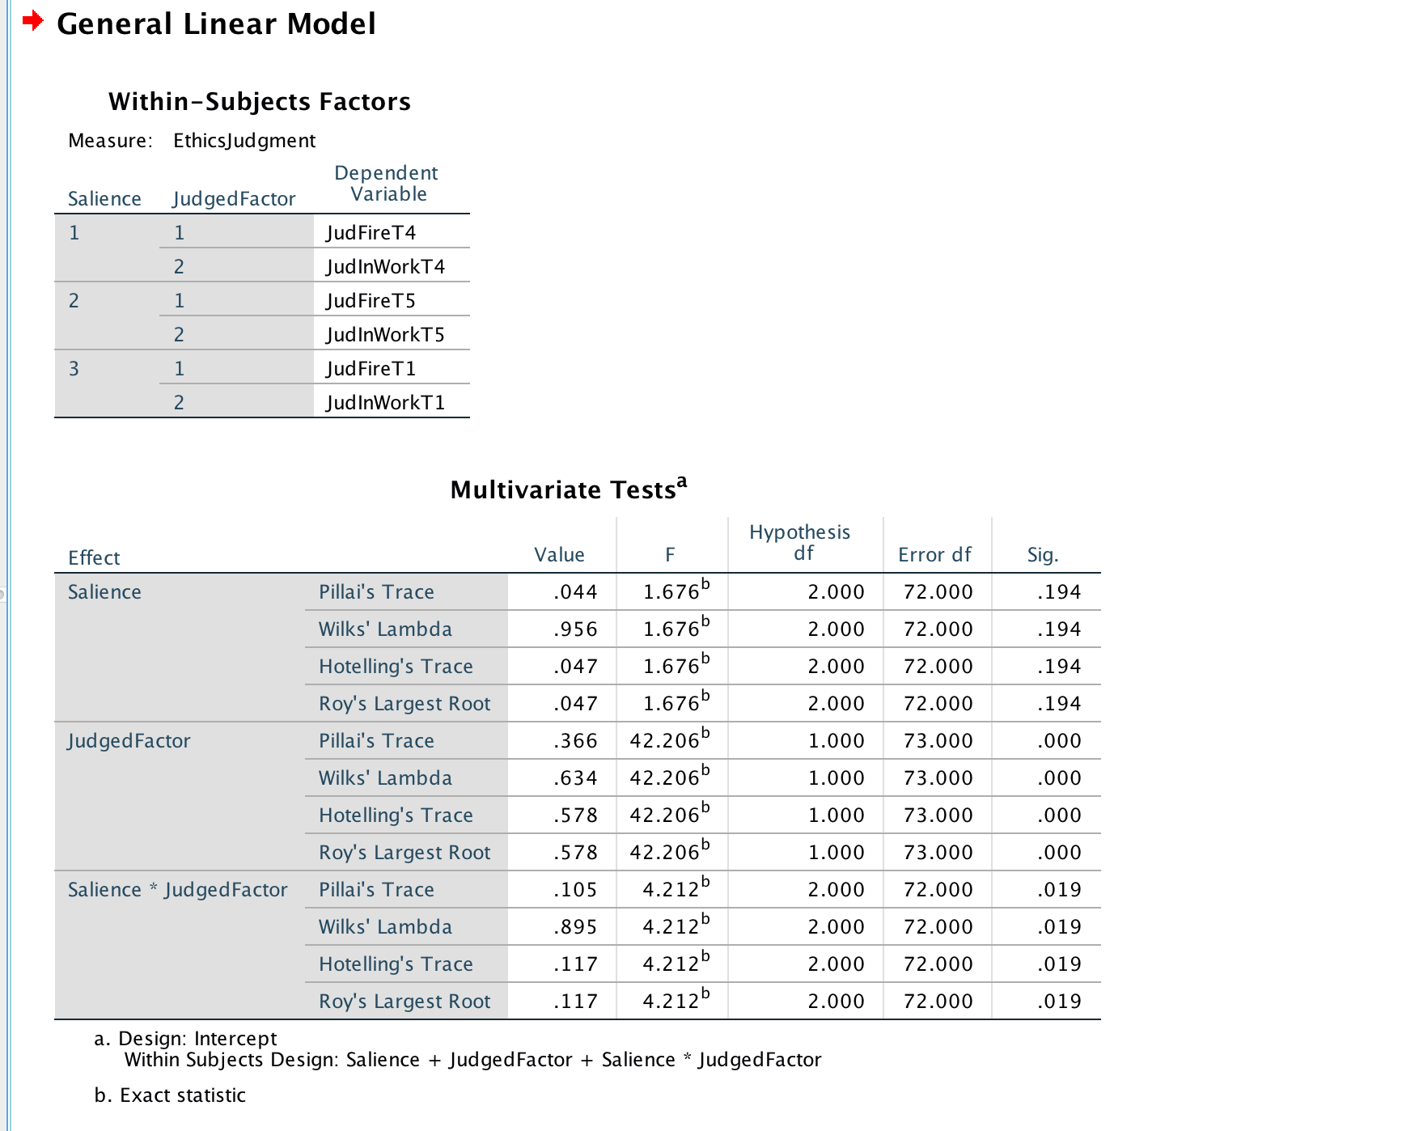

**Fig 1.a.**

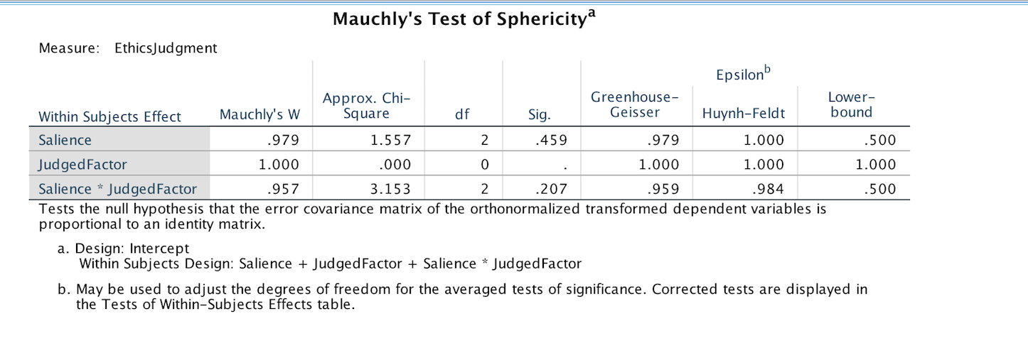

**Fig 1.b.**

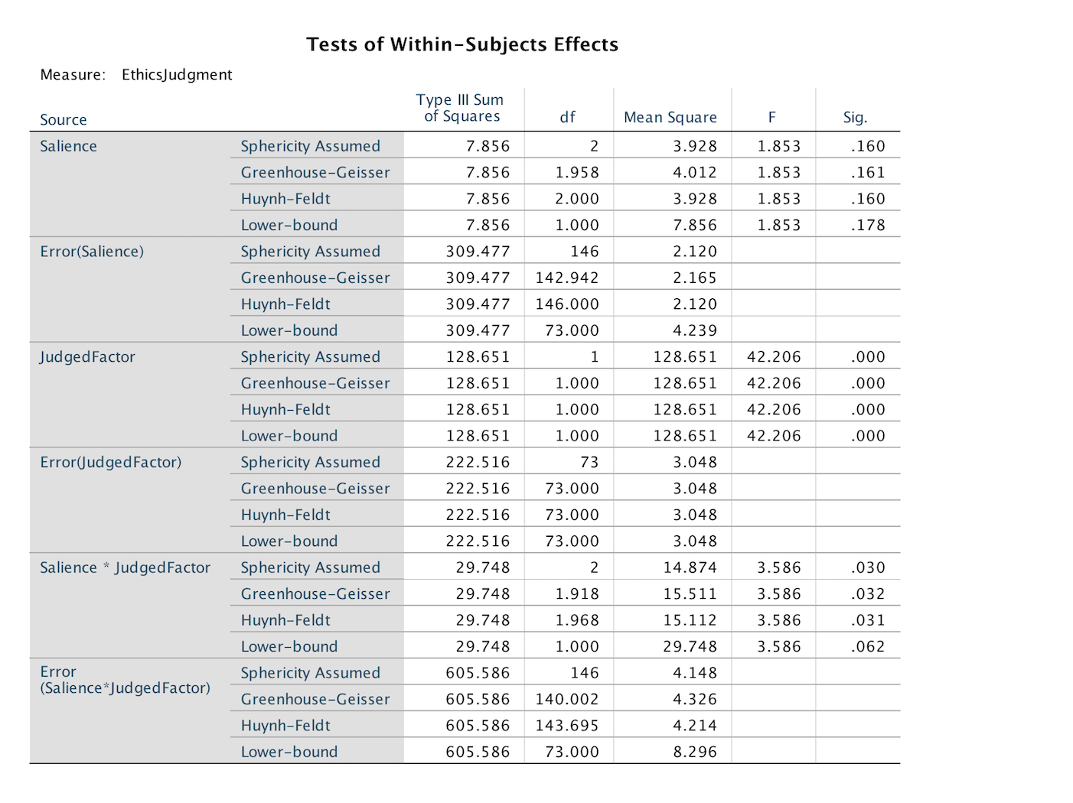

**Fig. 1.c.**

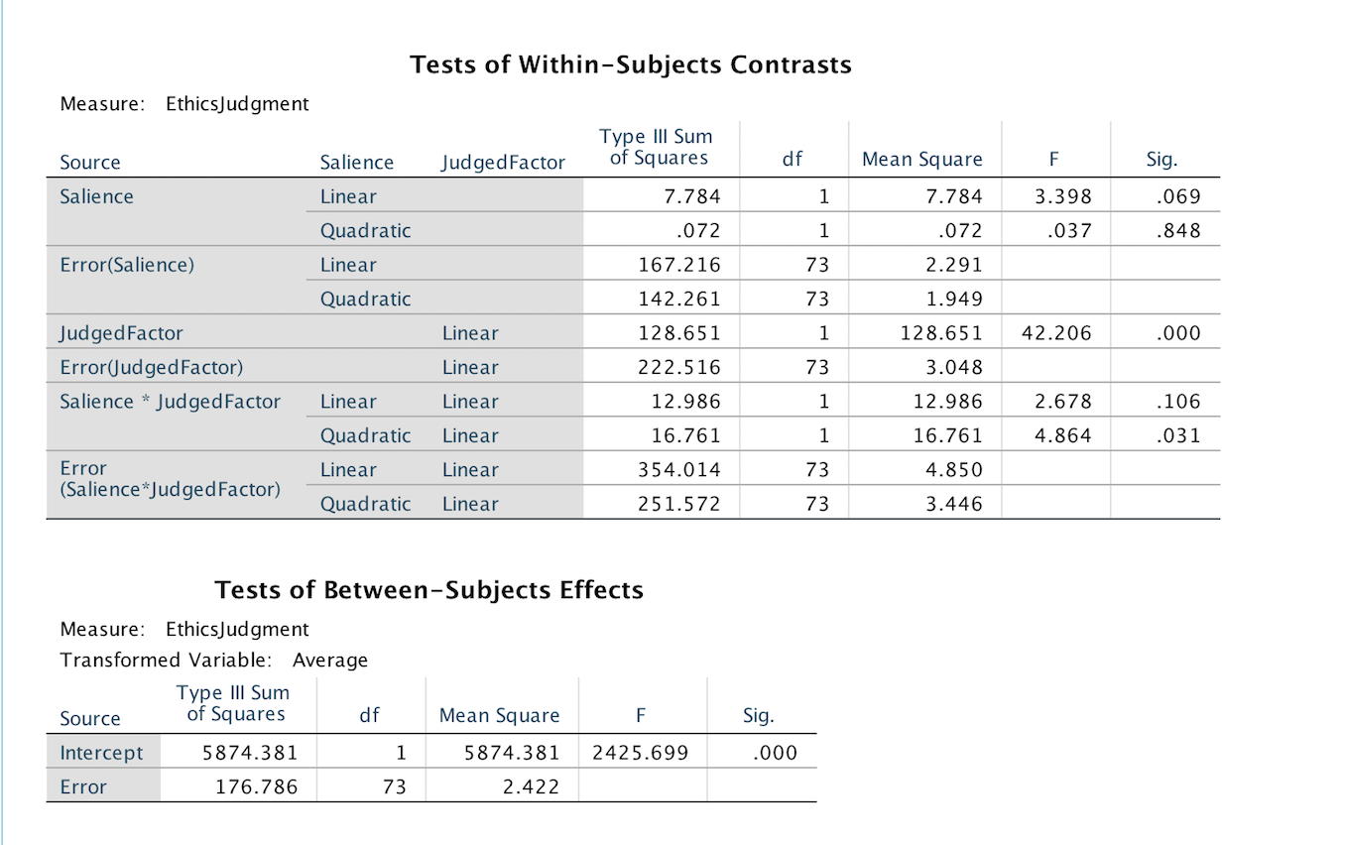

**Fig 1.d.**

1. Repeated Measure ANOVA, to examine the effect of one independent variables on ethics judgments for the topic fire: victim salience, which has 3 factors (Team 1/4/5)

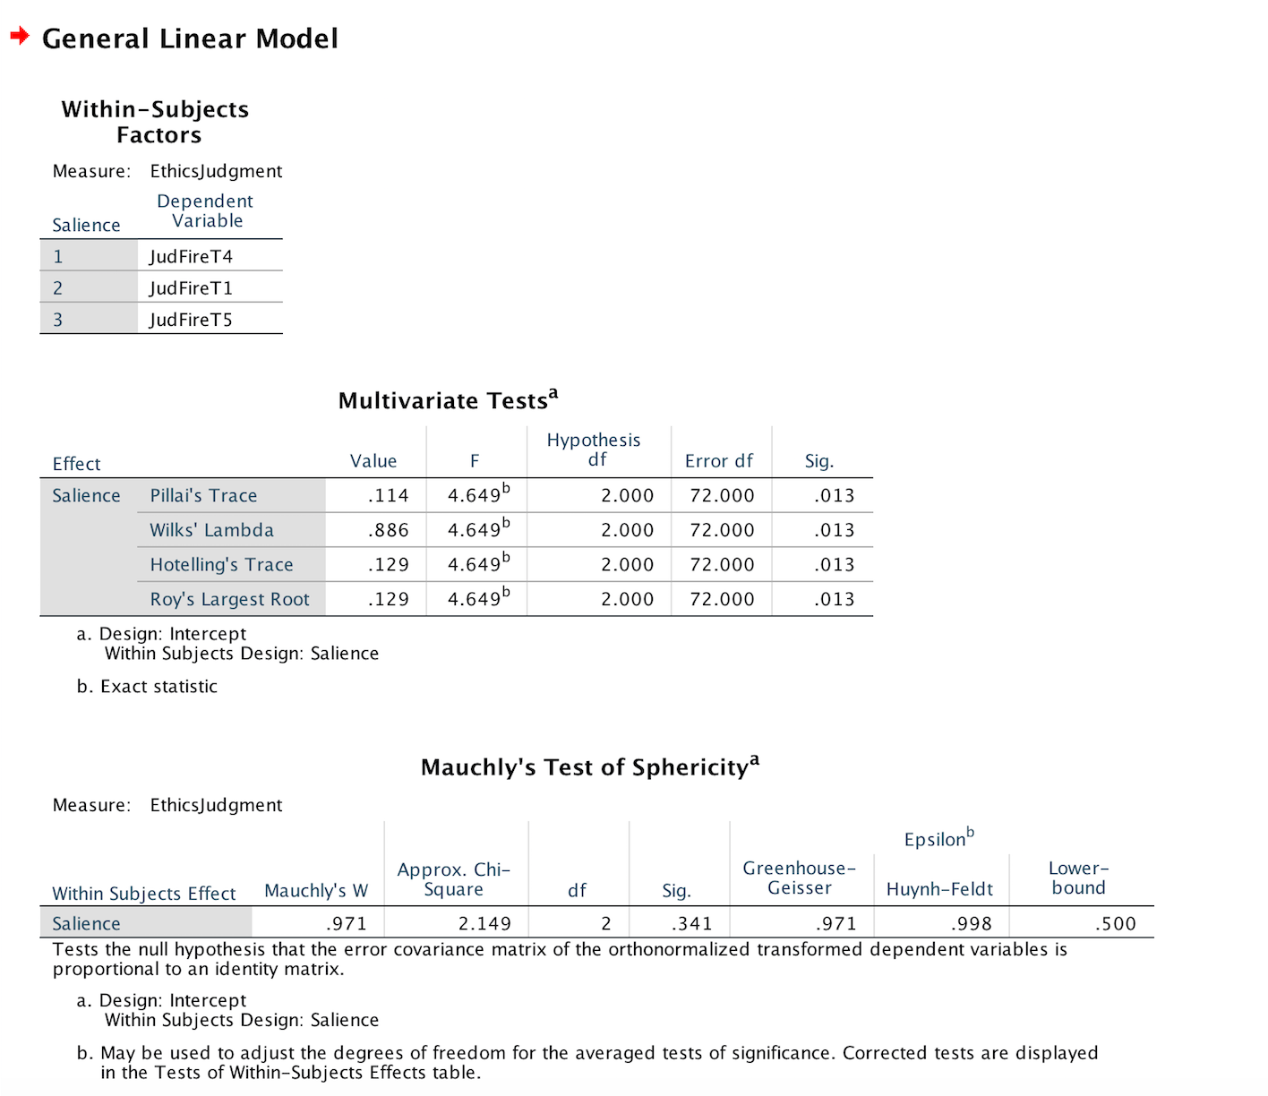

**Fig. 2.a.**

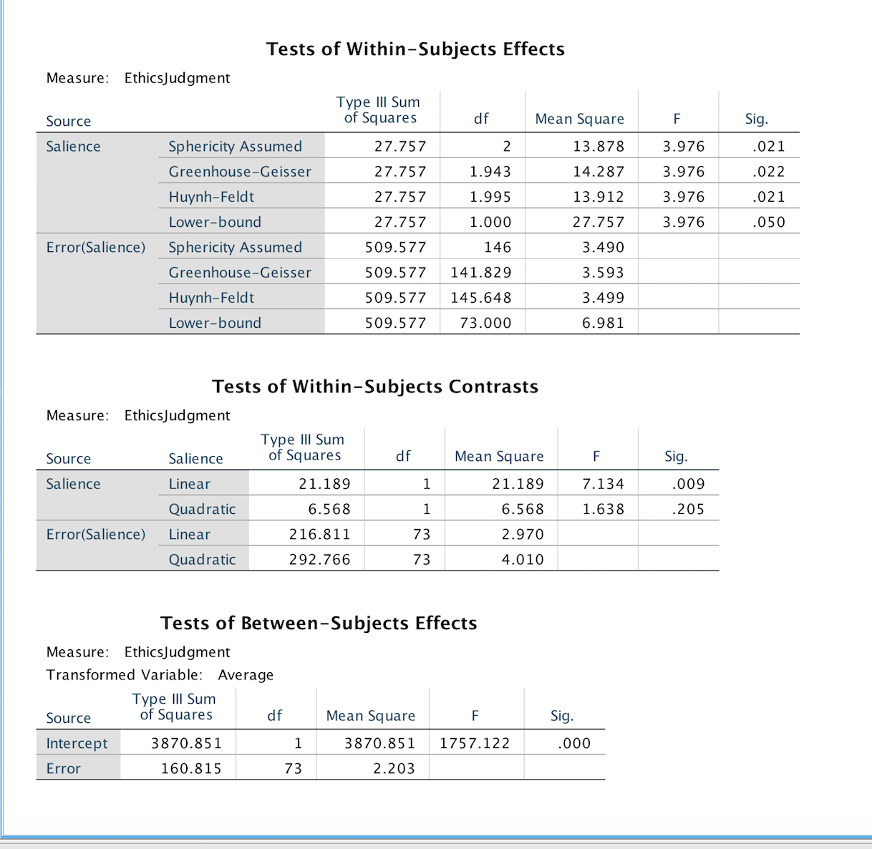

**Fig. 2.b.**

1. Repeated Measure ANOVA, to examine the effect of one independent variables on ethics judgments for the topic workload increase: victim salience, which has 3 factors (Team 1/4/5)

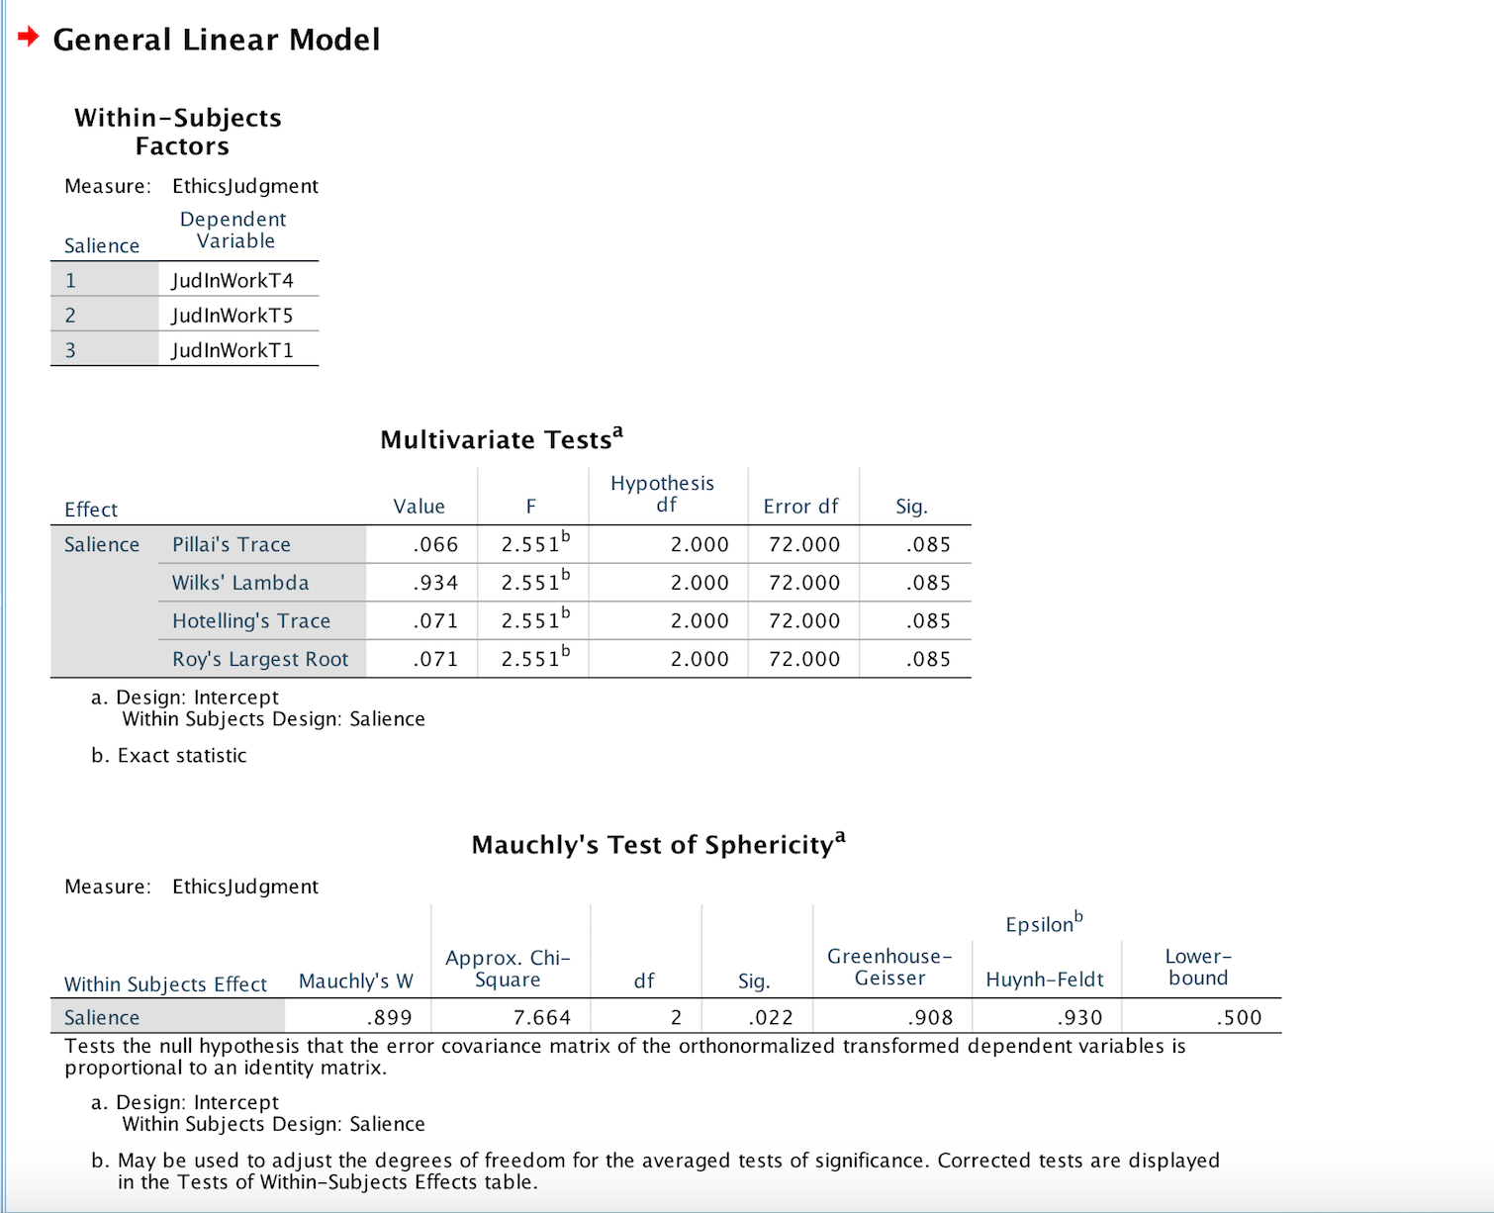

**Fig. 3.a.**

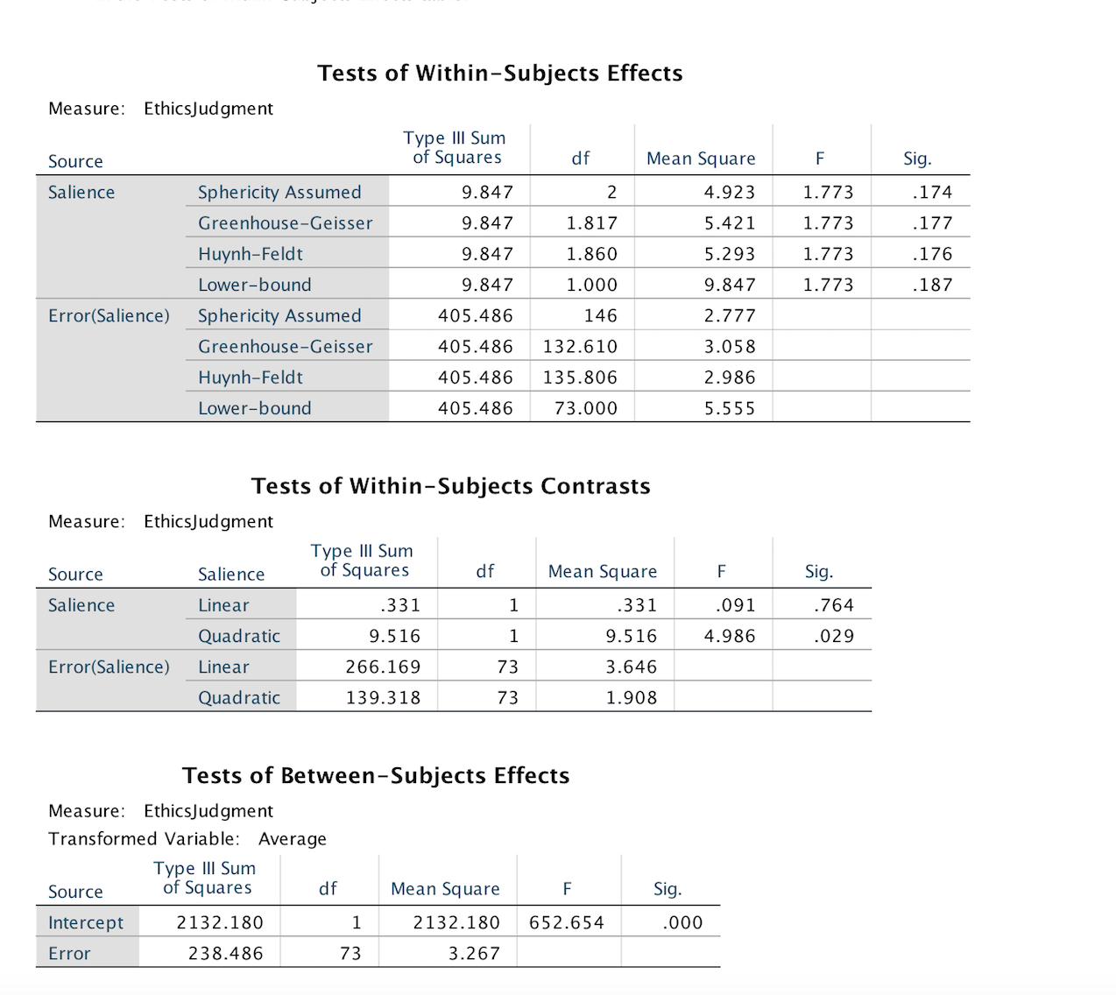

**Fig 3.b.**

1. Descriptive statistics for the effect of victim salience (3 factors) on ethics judgments for the topic fire:

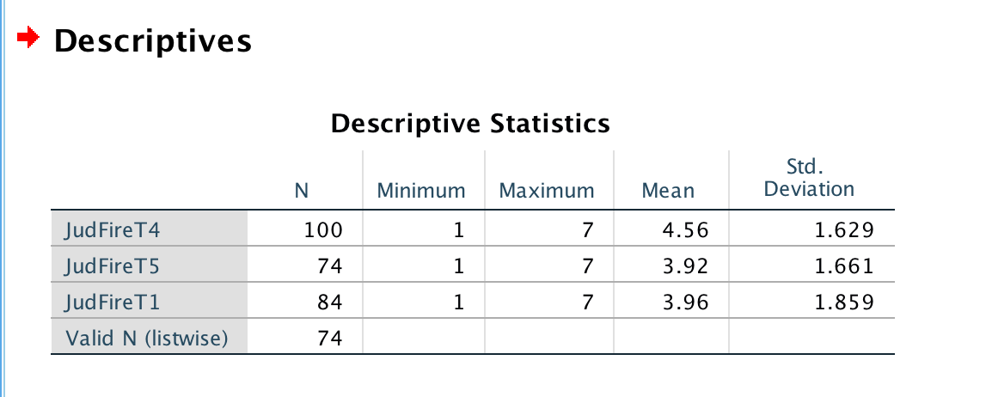

**Fig. 4.**

1. How Salience affects Ethics Judgments when judging the ethicality of firing an employee - Independent Sample t test comparing team 1 (salience not mentioned) and team 4 (high workload increase salience)

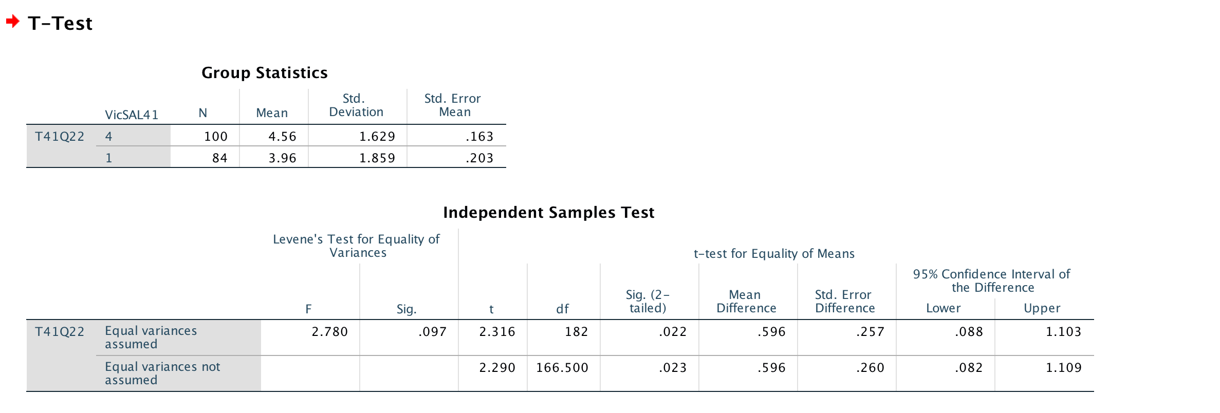

**Fig 5.**

1. How Salience affects Ethics Judgments when judging the ethicality of firing an employee - Independent Sample t test comparing team 1 (salience not mentioned) and team 5 (high firing salience)

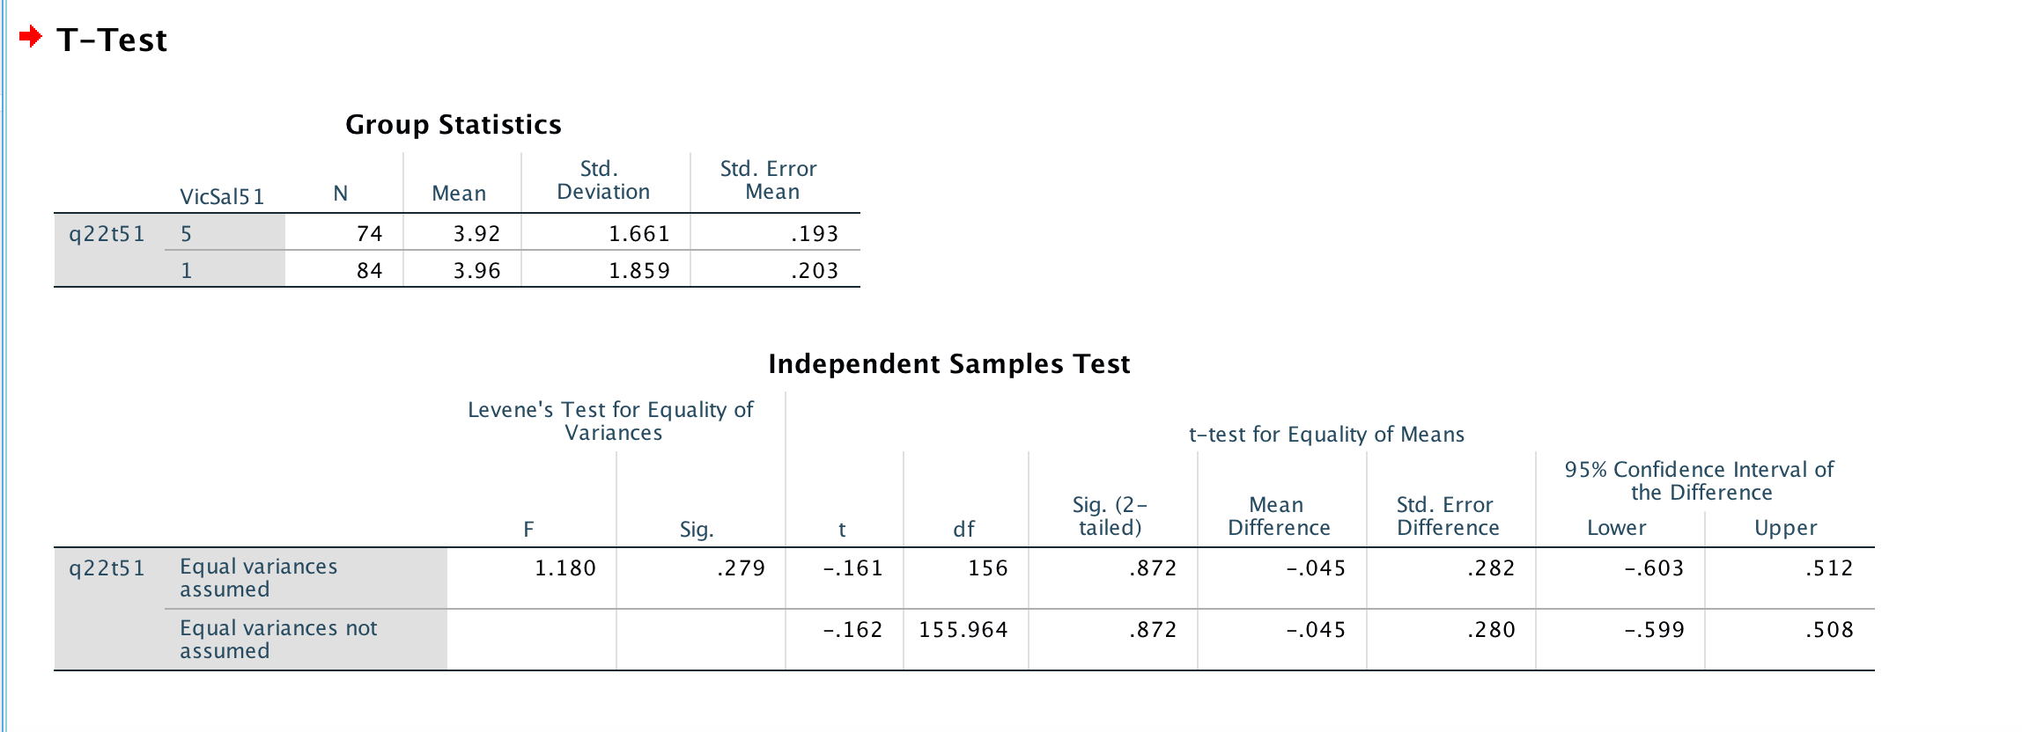

**Fig. 6.**

1. How Salience affects Ethics Judgments when judging the ethicality of firing an employee - Independent Sample t test comparing team 5 (high firing salience) and team 4 (high workload increase salience)

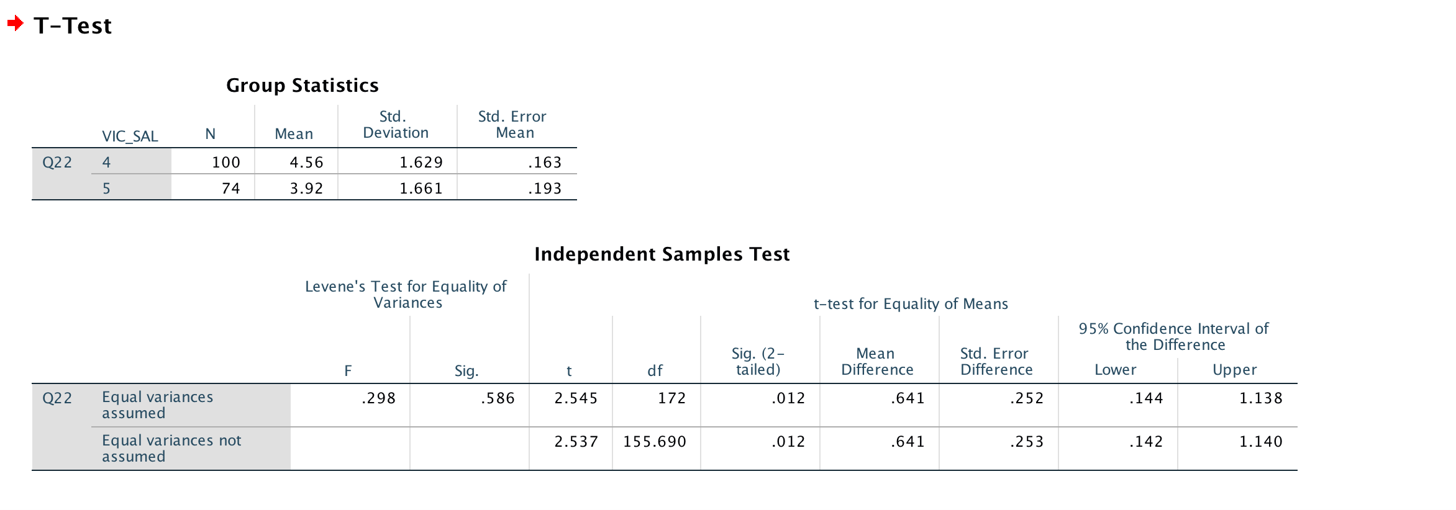

**Fig. 7.**

1. **Harm consideration**

**8.** Independent sample t-test testing ethicality judgments of firing an employee - no harm consideration (0), harm consideration (6)

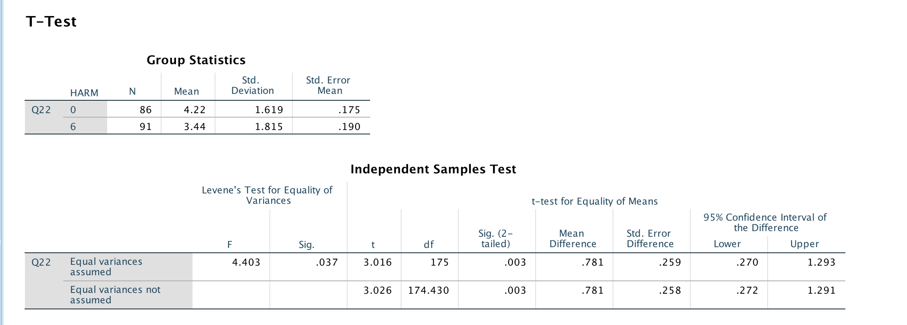

**Fig. 8.**

**9.** Independent sample t-test testing ethicality judgments of workload increase - no harm consideration (0), harm consideration (6)

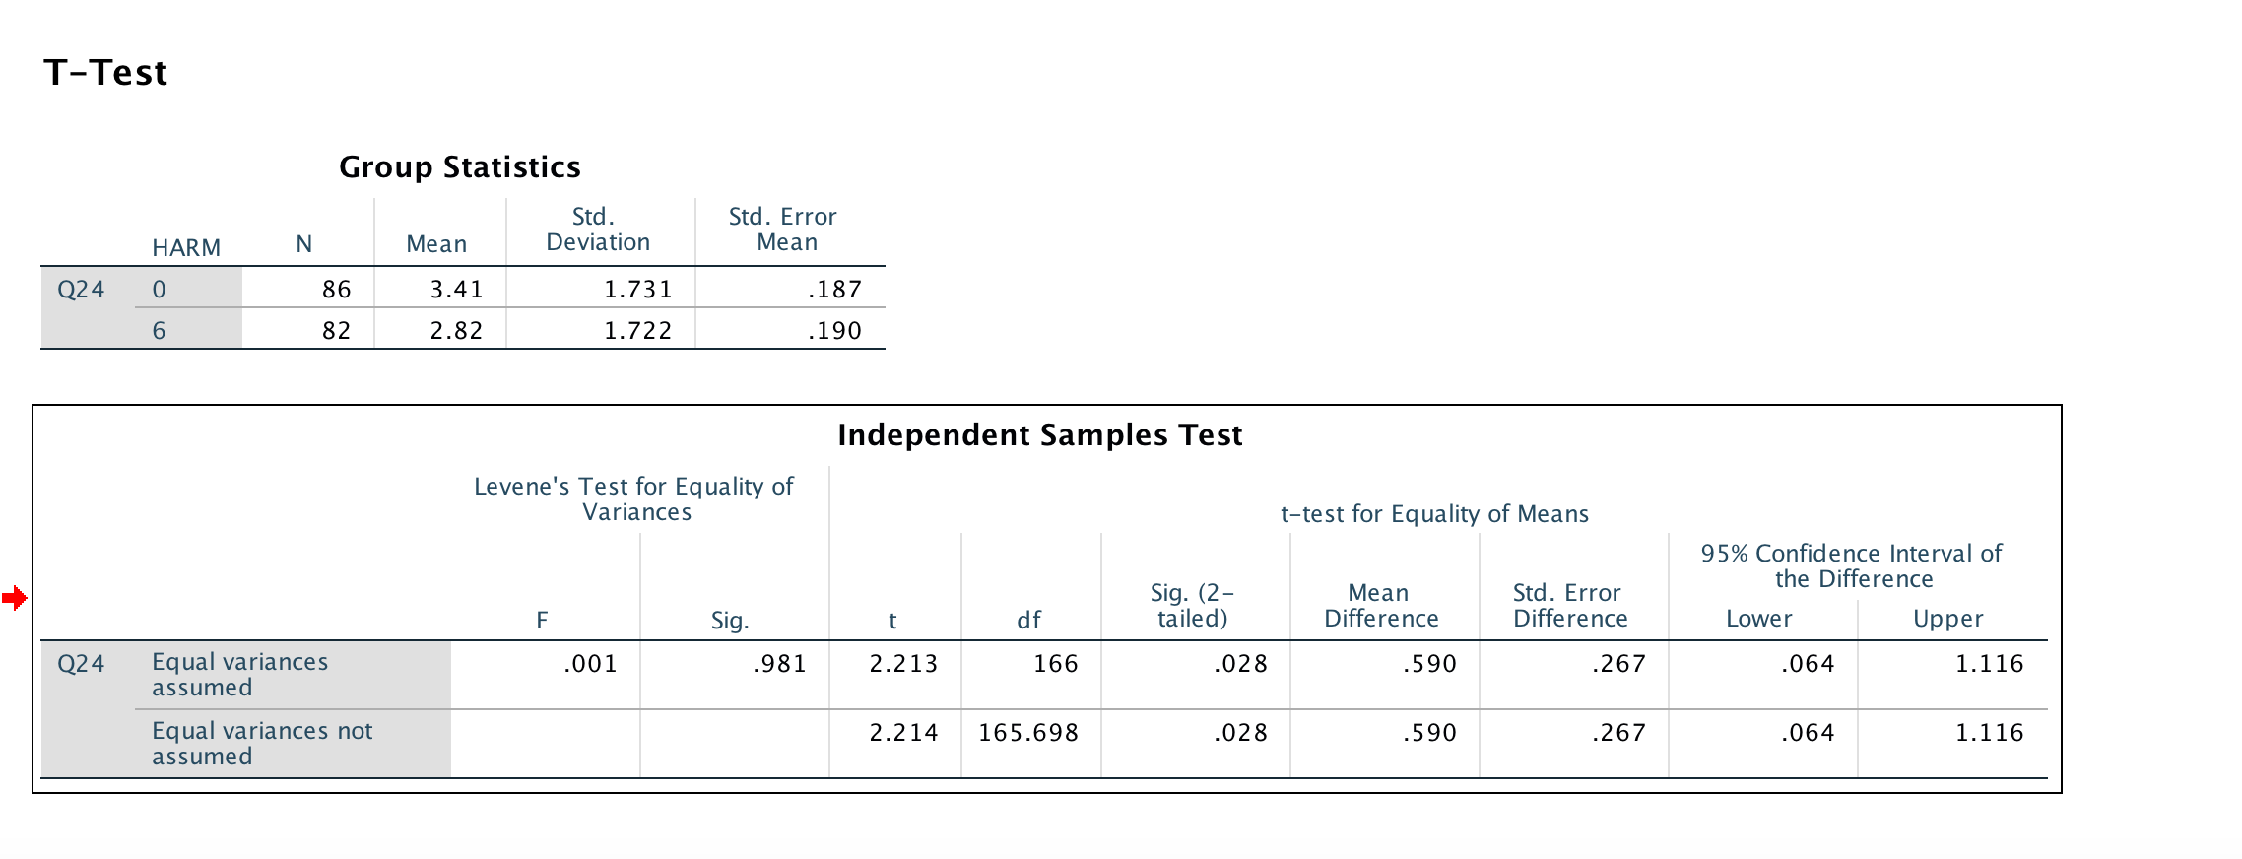

**Fig.9.**

**3. Gender**

**10.**  Independent Sample t-test comparing the means of gender (male/female) for both topics (fire / workload increase):

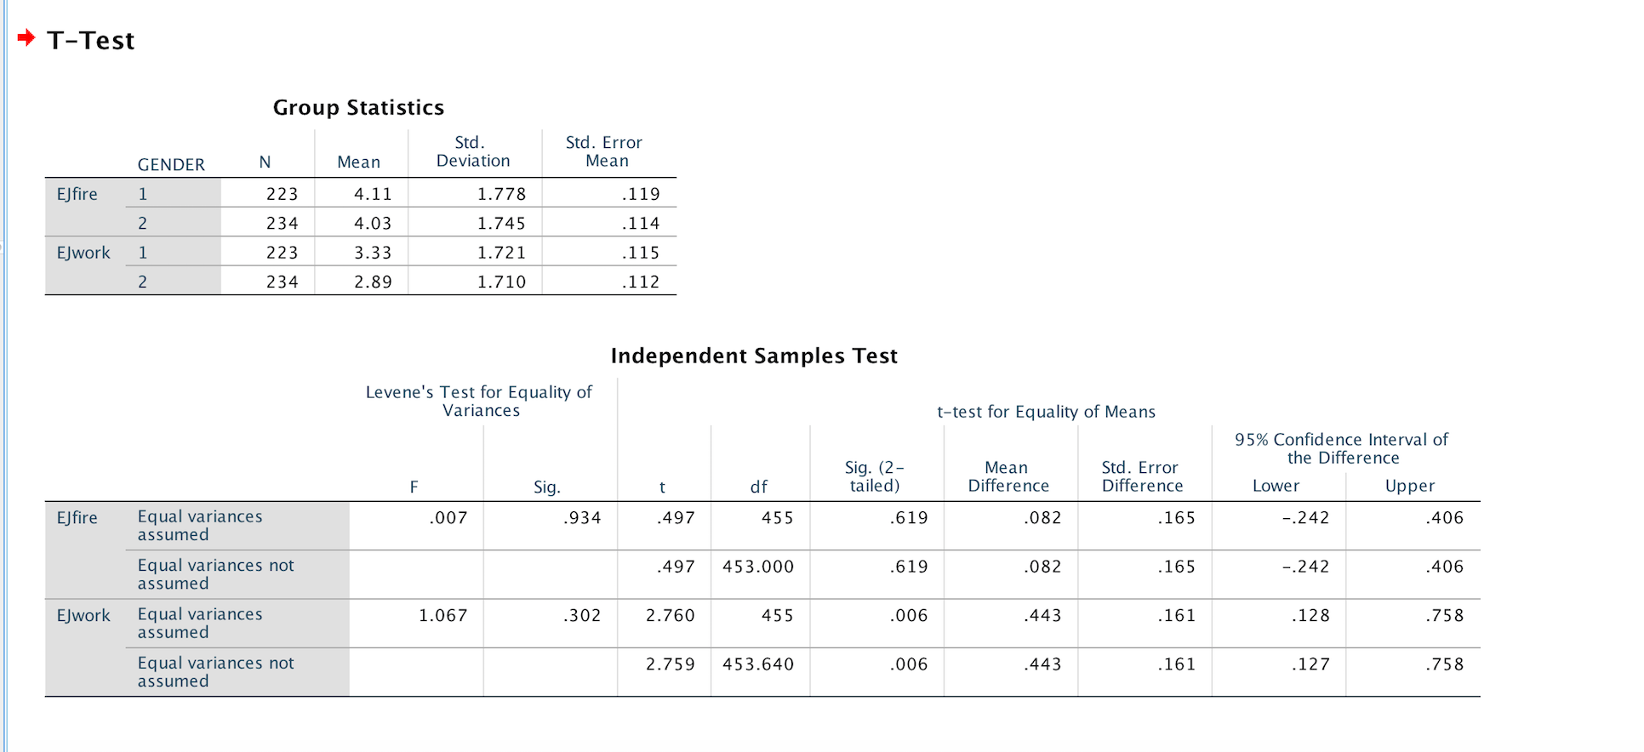

**Fig 10.**

**REFERENCES**

Akaah, I. (1989). Differences in research ethics judgments between male and female marketing professionals. *Journal Of Business Ethics*, *8*(5), 375-381. doi: 10.1007/bf00381729

Caplan, R., Vinokur, A., Price, R., & Van Ryn, M. (1989). Job seeking, reemployment, and mental health: A randomized field experiment in coping with job loss. *Journal Of Applied Psychology*, *74*(5), 759-769. doi: 10.1037/0021-9010.74.5.759

Chen, C.-W., Tuliao, K. V., Cullen, J. B., & Chang, Y.-Y. (2016). Does gender influence

managers’ ethics? A cross-cultural analysis. Business Ethics: A European Review, 25(4), 345–362. doi: 10.1111/beer.12122

Donovan, A., & Oddy, M. (1982). Psychological aspects of unemployment: an investigation into the emotional and social adjustment of school leavers. *Journal Of Adolescence*, *5*(1), 15-30. doi: 10.1016/s0140-1971(82)80015-8

Ford, R., & Richardson, W. (1994). Ethical decision making: A review of the empirical

literature. *Journal Of Business Ethics*, *13*(3), 205-221. doi: 10.1007/bf02074820

Gowan, M., & Gatewood, R. (1997). A model of response to the stress of involuntary job loss.

*Human Resource Management Review 7(3)*,277-297.doi:10.1016/s1053-4822(97)90009-7

Jones, S., & Hiltebeitel, K. (1995). Organizational influence in a model of the moral decision process of accountants. Journal Of Business Ethics, 14(6), 417-431. doi: 10.1007/bf00872084

Khazanchi, D. (1995). Unethical behavior in information systems: The gender factor. *Journal*

*Of Business Ethics*, *14*(9), 741-749. doi: 10.1007/bf00872327

Kidwell, J., Stevens, R., & Bethke, A. (1987). Differences in ethical perceptions between male and female managers: Myth or reality?. *Journal Of Business Ethics*, *6*(6), 489-493. doi: 10.1007/bf00383291

LeanaI, C., & Feldman, D. (1990). Individual Responses to Job Loss: Empirical Findings from

Two Field Studies. *Human Relations*, *43*(11), 1155-1181. doi: 10.1177/001872679004301107

Maclagan, P. (2012). Conflicting obligations, moral dilemmas and the development of

judgement through business ethics education. Business Ethics: A European Review, 21(2), 183–197. doi: 10.1111/j.1467-8608.2011.01645.x

Musbah, A., Cowton, C., & Tyfa, D. (2014). The Role of Individual Variables, Organizational

Variables and Moral Intensity Dimensions in Libyan Management Accountants’ Ethical

Decision Making. *Journal Of Business Ethics*, *134*(3), 335-358. doi:

10.1007/s10551-014-2421-3

McNichols, C., & Zimmerer, T. (1985). Situational ethics: An empirical study of differentiators of student attitudes. *Journal Of Business Ethics*, *4*(3), 175-180. doi: 10.1007/bf00705616

Ruegger, D., & King, E. (1992). A study of the effect of age and gender upon student

business ethics. *Journal Of Business Ethics*, *11*(3), 179-186. doi:

10.1007/bf00871965

Tsalikis, J., & Ortiz-Buonafina, M. (1990). Ethical beliefs' differences of males and females. *Journal Of Business Ethics*, *9*(6), 509-517. doi: 10.1007/bf00382844

Wang, L. C., & Calvano, L. (2013). Is Business Ethics Education Effective? An Analysis of

Gender, Personal Ethical Perspectives, and Moral Judgment. Journal of Business

Ethics, 126(4), 591–602. doi: 10.1007/s10551-013-1973-y

Ward, S., & King, L. (2018). Individual differences in reliance on intuition predict harsher moral

judgments. Journal of Personality and Social Psychology, 114(5), 825-849.

Welsh, D. T., & Ordóñez, L. D. (2014). Conscience without Cognition: The Effects of

Subconscious Priming on Ethical Behavior. Academy of Management Journal, 57(3),

723–742. doi: 10.5465/amj.2011.1009

Zhong, C.-B. (2011). The Ethical Dangers of Deliberative Decision Making. Administrative

Science Quarterly, 56(1), 1–25. doi: 10.2189/asqu.2011.56.1.001

**Default assessment: The contribution of each of the team members to the work**

|  |  |
| --- | --- |
| Gauri Munjal | Writing the *Conclusion* |
| Isabella Mandich | Writing the *Introduction* |
| Tania Turdean | Writing the *Results* section |

We all collaborated on rereading other members’ writing.